Rescaling and Comparing Power FC Maps Using Copilot

Introduction

There are many Power FC data files (*.dat) available on the Internet. Each one has been or should have been tuned for a particular car. Although the cars may have the same type of engine, differences from one car/engine to another, such as intake, injectors, header, exhaust, and internal work, would account for some of the differences we would find in the Power FC data files. For example, two 2ZZ-GE engines may be tuned such that the actual Air/Fuel Ratios (AFRs) throughout the 20 by 20 maps are the same, yet they may have different maps and/or settings. The rest of the differences would be due to the interesting things that a particular tuner did in terms of target AFRs achieved, ignition timing, VVT-i timing, and various settings. In order for others with the same type of engine to take advantage of good tuning by someone else, there should be three basic ingredients:

- Knowledge which the tuner, or in some cases owner of the car, can provide, such as intake diameter, injector sizes, and tuning methodology. An example of what I mean by tuning methodology would be compensating for a different intake or Mass Airflow Sensor by using the airflow curves or just using the standard airflow curve and changing the Base Map. Sometimes one can deduce these things by comparing data, but it will save time and help avoid confusion if the tuner provides this information.
- A means of “comparing apples to apples”. For example, one Power FC data file may have the entire Injector Correction (Inj) map set to 1.0 (using FC Edit’s or Copilot’s Recalculate Base function). Another example, which will be illustrated in this document, is using different Map Reference settings.
- A means of adapting/modifying data so that it may be utilized in another person’s car, including fine-tuning and street tuning.

We could spend a lot of time talking about three of the above, but I would like to dive right into an example, especially since there is a new Rescale Maps function in Copilot version 1.4.1. I added this so that I would be able to compare Power FC data produced by JesseIL, who is highly respected among Toyota Celica owners (www.newcelica.org). I will actually be using a data file that I got from “LittleRocket” (of www.spyderchat.com) which may have been modified some for a particular MR2 Spyder owner’s car (Tom’s)... I don’t know but will find out later. For the purposes of this document, we will just refer to this as Tom’s Power FC data file.

JesseIL found some good power gains by changing VVT-i and timing maps (and perhaps base maps? we will see). He also changed the Map Reference tables (compared to what most other people use). I am currently using a different set of Map Reference tables, too, because my engine can be safely revved above 9000RPM by virtue of having better valves and springs from Monkeywrench Racing ( www.monkeywrenchracing.com ). Due to the different Map Reference tables, in order to compare maps (Base, Inj, Ign, VVT-I), I need to rescale either his maps or mine. What I will do is rescale mine to be like his (working in a “sandbox” folder on my PC), compare and save screenshots of the maps and their differences, and then modify the Map Reference RPM table again to give it a larger range.

Before we dive right in, a little background about Copilot vs FC Edit is in order. Copilot has better map comparison than FC Edit, so I will be using that for most comparisons. Some data is not even read by Copilot, though, for example airflow curves and some of the settings, so to compare things other than maps, I will use FC Edit. Copilot also stores data differently than FC Edit. Whereas FC Edit stores everything in one big file (e.g., Tom.dat), Copilot stores like data together in separate files like BaseMap.pfc, InjMap.pfc, VVTMap.pfc, MapRef.pfc, and so on. This is so they can be read, opened, saved, written, copied, and replaced as units, even combining one person’s maps with someone else’s in a folder. The folder is the complete data set, not just one file. Copilot also uses the technique of separating Current (“Curr”) and New maps and files (NewBaseMap.pfc, NewInjMap.pfc, etc.), with New maps being the only ones that Copilot lets you modify or modifies itself (other than opening files and read from the Power FC into the Curr maps).

So what I had to do first was get Tom’s FC Edit format .dat file into Copilot format. This will be described in the next section, which is Part I of the document. Part II will cover rescaling maps. Part III will cover comparison (apples to apples), analysis, and modification. Part IV will be starting a new Auto Tune phase using fresh data from your “sandbox”. If you just want to use someone else’s FC Edit format file and auto tune with it, you can skip Part III (which I am not going to write until later anyway!).

Part I – Using Someone Else’s FC Edit Data with Copilot

- Connect your computer to Datalogit and turn the key on (no need to start the engine).
- Assuming you have been working in Auto Tune Operating Mode, your current data will already be in an AutoTune subfolder, so skip this step and go to the next one. If you have been working in Manual Edit mode, we can “fix” that now by copying everything in the ManualEdit\ folder (probably “C:\Program Files\Copilot\ManualEdit\”) into a subfolder of the AutoTune folder that you create. Example: Create a folder called “feb07” in “C:\Program Files\Copilot\AutoTune\”. Copy everything in “C:\Program Files\Copilot\ManualEdit\” into the new folder, “C:\Program Files\Copilot\AutoTune\feb07\”. Start Copilot, uncheck Work Offline, and select Auto Tune Operating Mode. Copilot will automatically read all the data it is interested in (which as of version 1.4.1 includes Map Reference). Since you were working in Manual Edit mode before, select File→Open AutoTune Folder, locate that directory you created in the previous step, and click OK. Make sure all your New maps are the same as Curr maps as follows:
- Select the tab (Fuel, Ignition, or VVT-I) for the map(s) you will work with.
- Select the Curr map (Curr Base, Curr Inj, Curr Ign (Leading and Trailing if 1ZZ-FE), or Curr VVT).
- Click the small button in the upper left corner of the map to select all cells.
- Click the Copy button.
- Select the New map (New Base, New Inj, New Ign (Leading and Trailing if 1ZZ-FE), New VVT).
- Select all cells in that map.
- Click the Paste button.
- To verify they are the same (Curr vs New), select the Diff option. All cells should be blank (no differences). Note that there are sometimes very small, insignificant differences due to conversion errors after writing New maps and reading them back into Curr maps, but in the case of copying/pasting, this should not occur.
- (Optional) Click the Save (whatever new) map button. This will not be necessary in this case because Copilot will save all maps before exiting (unless you select Quit Without Saving from the File menu). I am just showing this for illustration purposes.
- Exit Copilot (close the window or select File→Exit).
- Make sure you have a backup of all your current Power FC settings, including the things Copilot does not deal with, using FC Edit. Click Read All. Verify that your maps and settings are displayed. From the File menu, select SaveAs and save it. I saved to my latest Auto Tune folder (mine is “feb07”, which is “C:\Program Files\Copilot\AutoTune\feb07\”) as feb07.dat.
- Also using FC Edit, select File→Open, locate the new FC Edit format file (I named it Tom.dat), click Open. Then write it to the Power FC using the Write All button. Close FC Edit.
- Delete all files beginning with “New” in the ManualEdit folder. You will be recreating them based on what was read from the Power FC.
- Start Copilot, uncheck Work Offline, and select Manual Edit Operating Mode (this is why we copied your current data into another folder earlier). Copilot will automatically read all the data it is interested in (which now includes Map Reference). Click Stop Acquisition (this assumes that you have it set up to automatically start data acquisition at startup). Select Function→Rescale Maps (Map Reference) and just verify that the Current Map Reference Data is filled in and it says “valid” in green below that. Back on the main window, select View→Message Log. Move that window to the side so you can see messages. This is to confirm operations were successful. Click the Save button below Current Map Reference (first frame on the left). The program should have seen that there was no MapRef.pfc file when it started for the first time and therefore created the file, so this is just a check of that logic. Check for alerts/warnings in the Message Log. It should say something indicating that it was unable to open MapRef.pfc when it started, since that file did not exist, but then (depending on your Message Log options) indicate that it read the data and saved it to the file. Minimize the Rescale Maps (Map Reference) window and the Message Log window. Examine all the Current and New Maps. If you have worked in the ManualEdit\ folder before, they will not match. This isn’t very important, but to avoid confusion later, copy and paste each of the Current maps to the New maps. This is done as follows:
- Select the tab (Fuel, Ignition, or VVT-I) for the map(s) you will work with.
- Select the Curr map (Curr Base, Curr Inj, Curr Ign (Leading and Trailing if 1ZZ-FE), or Curr VVT).
- Click the small button in the upper left corner of the map to select all cells.
- Click the Copy button.
- Select the New map (New Base, New Inj, New Ign (Leading and Trailing if 1ZZ-FE), New VVT).
- Select all cells in that map.
- Click the Paste button.
- To verify they are the same (Curr vs New), select the Diff option. All cells should be blank (no differences). Note that there are sometimes very small, insignificant differences due to conversion errors after writing New maps and reading them back into Curr maps, but in the case of copying/pasting, this should not occur.
- (Optional) Reselect the New map and click the Save (whatever) button. The reason this is optional is that Copilot saves everything before it exits.
- Exit Copilot.
- Start FC Edit, click File→Open, locate the backup file of the data you had been working with (in my case, it was feb07.dat in my feb07\ subfolder of AutoTune\), and open it. Then click Write All. After is it is done, click Read All and verify that your Power FC is back in the state it was before loading the other person’s data into it (I don’t think FC Edit reads back the data after writing, unlike Copilot which does this for you). Exit FC Edit.
- Turn the key off.
- Now you can work offline, even on a different computer (just copy folders from laptop to desktop, which I do using a thumb drive).

Part II – Rescaling Maps

So at this point, you have two FC Edit files (yours: feb07.dat, other: Tom.dat) and two sets of Copilot format files in folders (yours: AutoTune\feb07\ and other: ManualEdit\) with old and new data and your Power FC contains the same data it did when we started. The next step is to make a copy of the ManualEdit folder that will always have the other person’s data in it (just as feb07 will always have our pre-modification data in it). We will not modify any the files in those folders. Using Explorer, copy the ManualEdit\ folder to another folder, let’s say “Tom” (“C:\Program Files\Copilot\Tom\” and also copy Tom’s FC Edit format file (Tom.dat) into that same folder.

For most of the rest of the job, we will be using the ManualEdit\ folder as our “sandbox”, copying files into and out of it and making changes as needed.

We already know that our Map Reference tables are different than Tom’s, so we can either change our Map Reference or Tom’s. Let’s modify ours, since Tom’s has more resolution in some areas and JesseIL said that it had to do with lowering the lift engagement RPM and having more control over VVT and timing in the upper RPM range.

ManualEdit\ currently contains the same thing as Tom\, so copy the contents of feb07\ into ManualEdit\ and start Copilot. Select Manual Edit operating mode and Work Offline if they are not already selected. It will read all the files. This is what I had at this point. (Note: all my “New” maps are the same as “Curr” maps.)

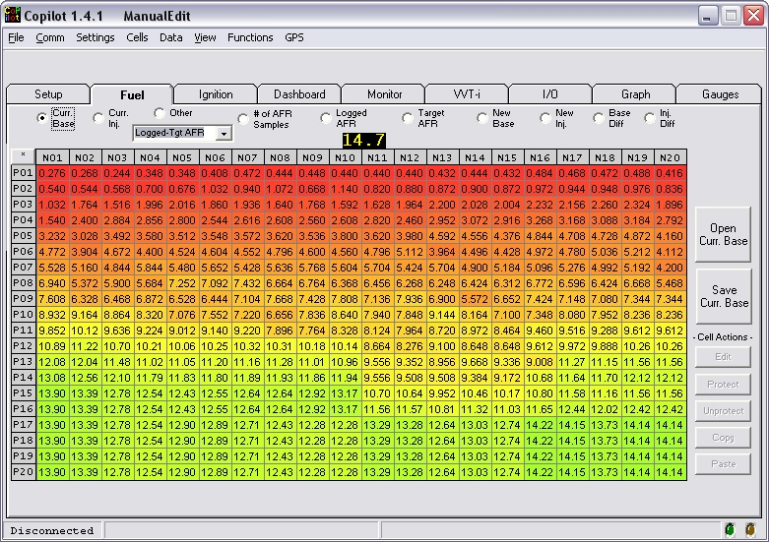
Base Map

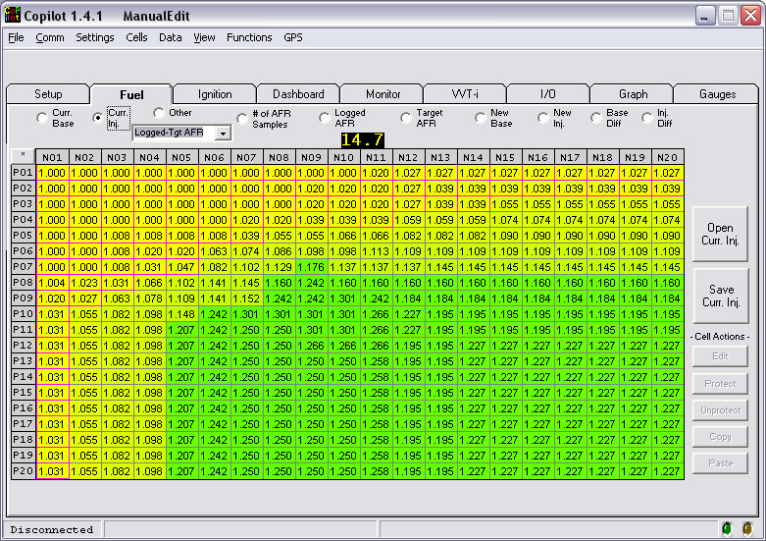
Inj Map (Note: Closed loop cells have magenta borders. I need to improve the color-coding so it is easier to spot differences, but it is quite a bit richer in the green area)
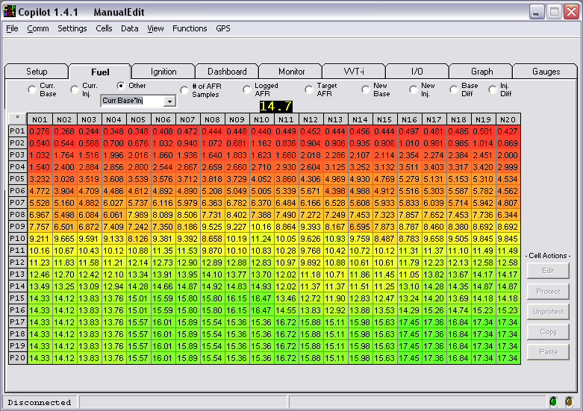
Base*Inj Map (select other and use list box to select Curr Base*Inj) This is what my Base map would be if I did Recalculate Base.
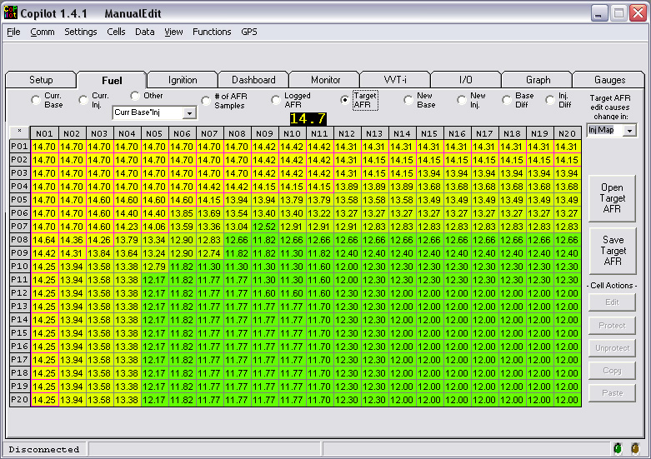
Target AFR Map (Note: cells which would be closed loop if Inj Map was tied to Target AFR map (which it is) have magenta border. Also observe in upper right corner that “Inj Map” is selected for “Target AFR edit causes change in”, which means that whenever I edit the Target AFR map, the corresponding cell(s) in the Inj map are automatically set to Inj = 14.7/AFR. I never have to edit the Inj map directly or do that conversion again. Having a map with AFR units also allows copying from Logged AFR (actual AFRs recorded from wideband and averaged per cell) into Target AFR and displaying Logged-Target under the “Other” option.)
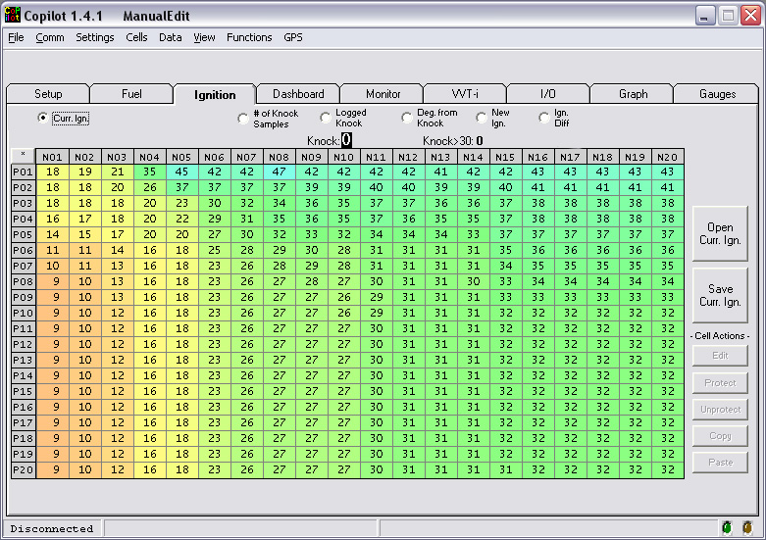
Ign Map This is mostly unchanged from what I got from LittleRocket when he did my 2ZZ engine swap. If you have a 1ZZ-FE engine, you will have two ignition maps, which are called Leading and Trailing, even though this naming convention is misleading. That is what they are called in FC Edit. One of them is supposedly a “safe” map, but the jury is out as to whether or not it actually works as a safe map or is even used in the Power FC.
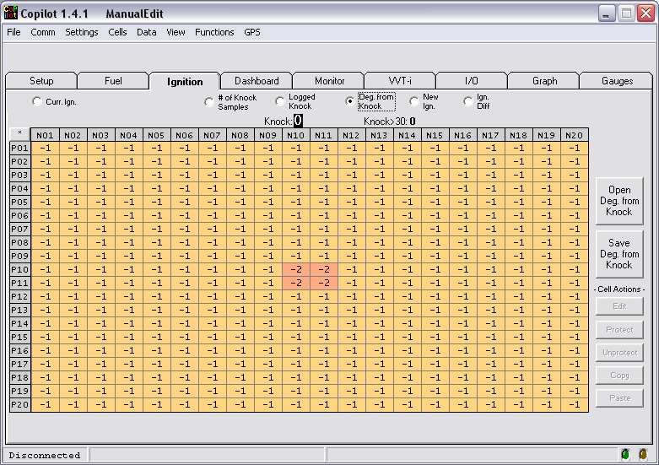
Deg. From Knock Map (Note: I just changed 4 cells so I could show how this map is rescaled along with all the others. The “Deg. From Knock” contains the number of degrees to add to the Ign map when knock above a user-defined threshold is seen. The threshold is “Knock to cause timing retard” on the Setup tab. Since the numbers in this map are expected to be negative numbers, adding will retard timing, which is what you want to happen. This map, like the Target AFR map, is not a Power FC map, but is used during Auto Tuning.)
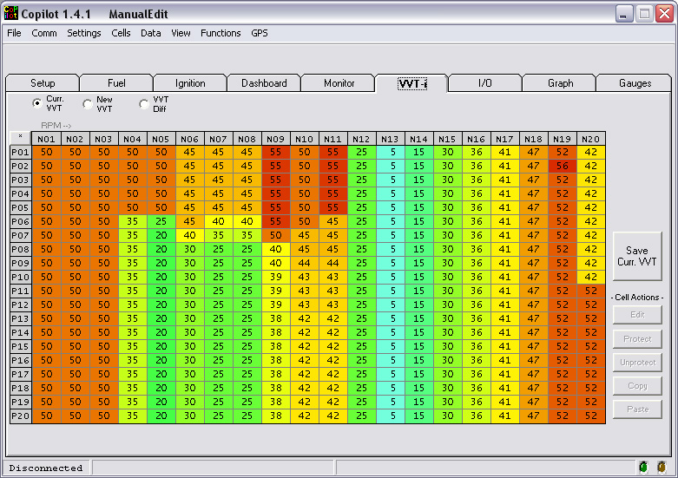
VVT Map (I believe this is the same data that I got from LittleRocket, or very close to it.)
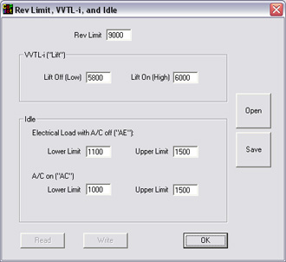
Rev Limit and Idle Settings. Rev Limit is set to 9000, but I have had it at 9300 before. This is why my current Map Reference RPM table goes up to 10000.
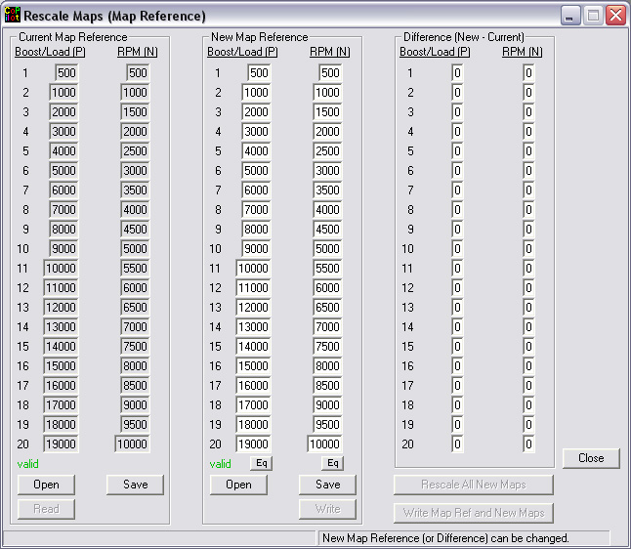
Rescale Maps (Map Reference) Since I have not rescaled my maps yet, New Map Reference is the same as Current Map Reference, so the differences are all 0. Since they are equal, the Rescale All New Maps button is disabled. This button will also be disabled if data is invalid. For data to be valid, the numbers must be increasing and greater than 0. The Boost/Load (P) table establishes the breakpoints for load, which corresponds to the 20 rows of each map. As you can see on the maps, rows are labeled P01 through P20, partly because there is not enough room for the load values. The RPM (N) table establishes the breakpoints for RPM. The highest Load and highest RPM in your Map Reference should be set to high enough (but not excessively high) a value. If found that the highest Load (row) I ever logged was P14, but would want to have some safety margin, especially since I do not normally drive in a hilly area (I’ve noticed that load is highest when going uphill at full throttle). P16-P20 are probably not reachable with a normally aspirated 2ZZ-GE engine. I had planned on rescaling my maps for this reason, even before finding out about JesseIL’s (Tom’s) improved maps. Incidentally, he said that he rescaled maps using an Excel spreadsheet. It probably does it the same way Copilot does, which is by linear interpolation and extending the slope near the edges in cases where the new Map Reference table has a smaller or larger value than any of the current ones. I will talk more about this window later as it is demonstrated.
To get Tom’s New Map Reference data, I replaced NewMapRef.pfc in the ManualEdit\ folder with the one from the Tom folder using Windows Explorer, then clicked Open in the New Map Reference frame. After doing that, the window looked like this:
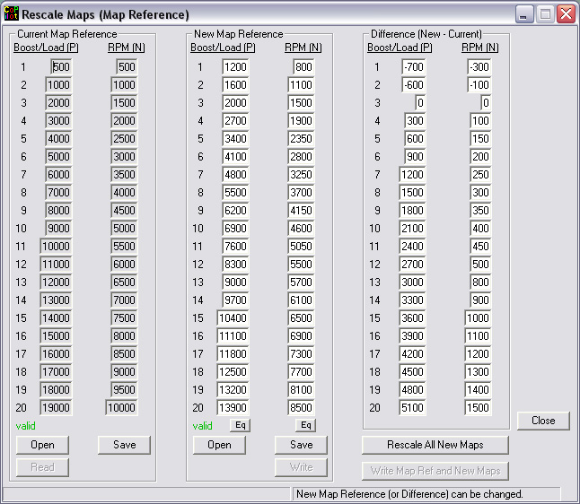
Current vs. New Map Reference ready to rescale all maps

Next I clicked Rescale All New Maps and right away got the dialog box that said it was done and asked me if I wanted to copy the new map reference to the current map reference. I clicked Yes because I am working offline. (If I were working online, the next thing to do, after comparing data to make sure everything is OK, would be to click the Write Map Ref and New Maps button. After writing the data to the Power FC, it will read it back and so my Current Map Reference tables would match the new ones.)

So let’s take a look at what happened to the New maps. The next several pages just contain screenshots of New maps and their differences.

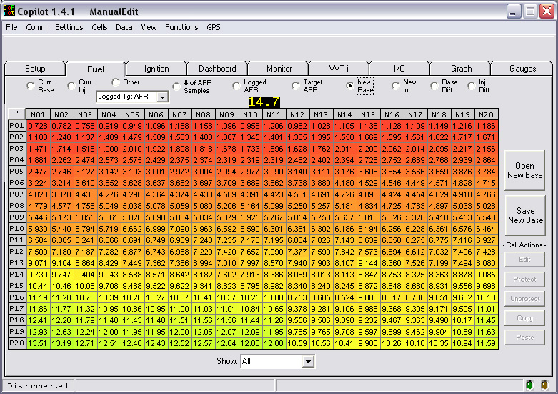
New Base

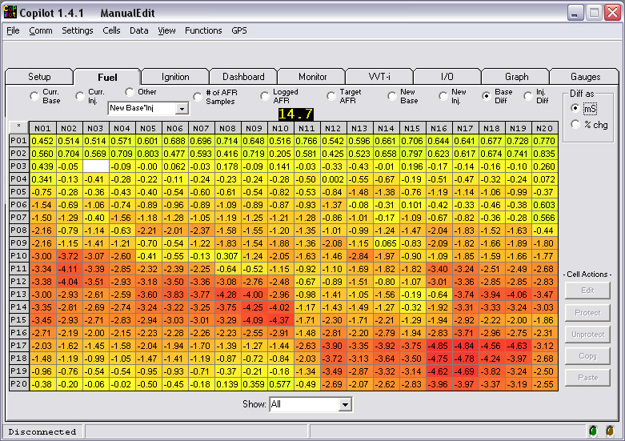
Base Diff (Note that the data is merely shifted and stretched/compressed to fit in the New Map Reference, so this difference display is just confirmation. The next page may be a better comparison… before and after screenshots of the Base Map)

Base Map before rescaling

Base Map after rescaling. As you can see, it is almost as if a magnifying glass was used. There is more detail because 20 rows are available to represent was in 14 rows before.

Base*Inj Map before rescaling (Curr Base*Inj selected for Other)

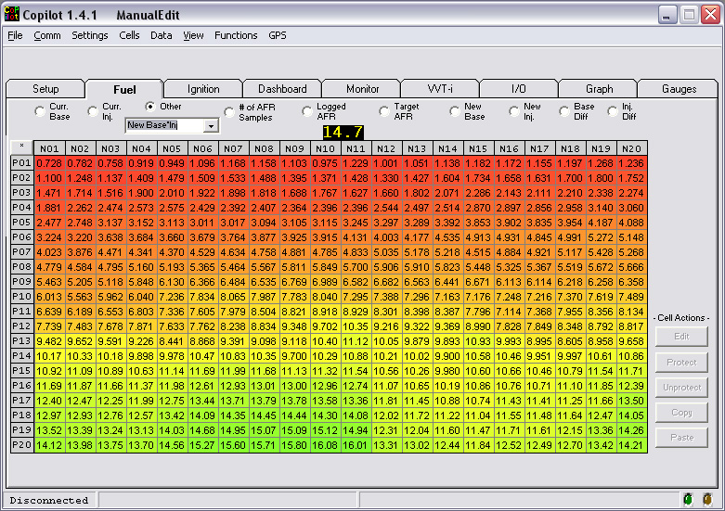

Base*Inj Map after rescaling (New Base*Inj selected for Other).
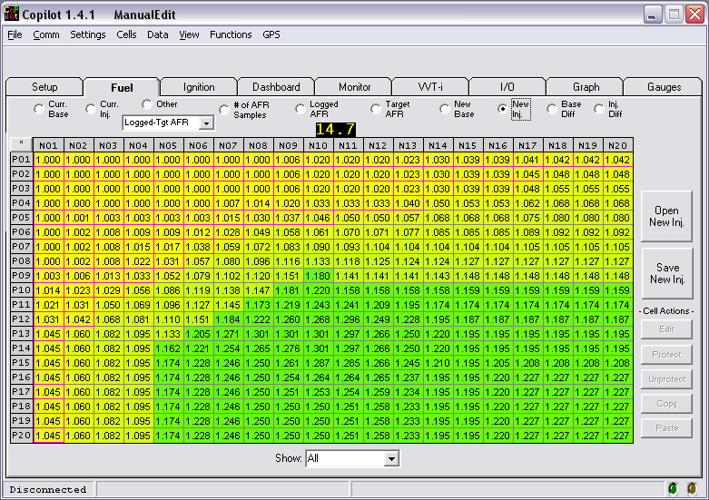
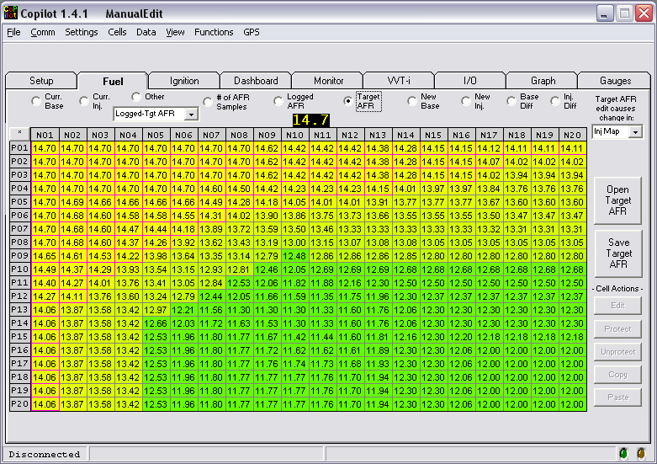
New Inj Map after rescaling

Target AFR Map after rescaling (Note: The program does not keep the old Target AFR Map, so you cannot show the difference or undo by copying. The only way you can undo ALL the rescaling is by selecting File→Quit without Saving or by copying your backup files into your “sandbox” (the ManualEdit\ folder).)

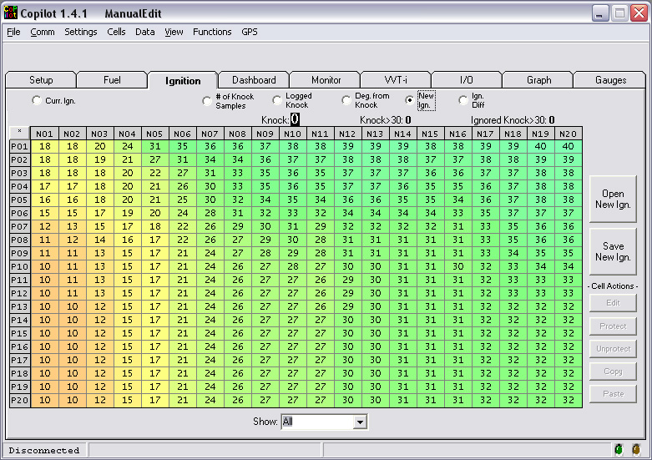
New Ign Map after rescaling
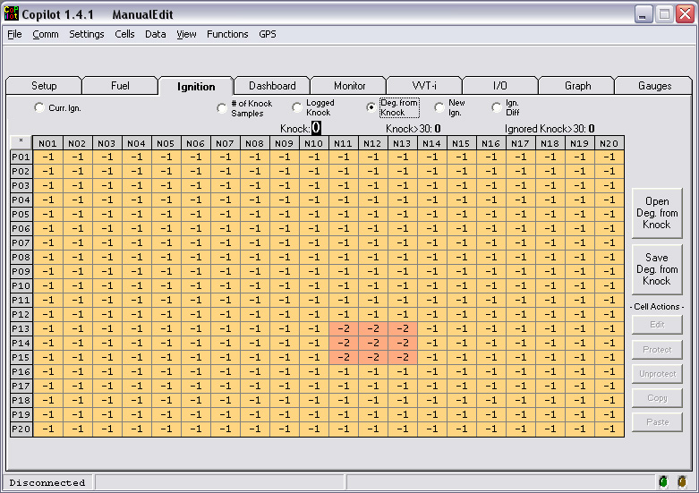
Deg. From Knock Map after rescaling (Note that I made a 2 by 2 patch of cells that were different before rescaling that was in P10-11, N10-11 and now it is in a 3 by 3 patch in P13-15, N11-13. It covers the same Load and RPM ranges as before. This was just for illustration purposes. I will make them all –1 before actually using the map for Auto Tuning ignition timing.)

VVT Map before rescaling
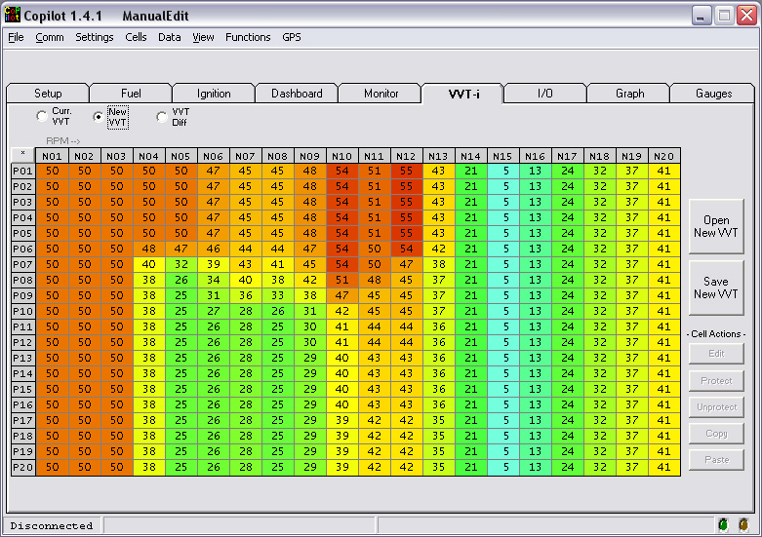

VVT Map after rescaling
Something you may not be aware of is the fact that New map files contain extra information about the cells. This is why the files are larger than Current map files. You can replace a Current with a New file (e.g., delete BaseMap.pfc and rename a copy of NewBaseMap.pfc to BaseMap.pfc) because when reading a Current file, it does not read beyond the expected number of bytes. When you save it, the extra information is lost. You can also replace a New file with a Current one. When Copilot reads the file, it may tell you that the extra information is missing, but it will read it anyway and all the extra information “flags” will have been reset/cleared in memory. When saved, the flags (all cleared) will be saved in the New map. This is all by design.

So why does that have to do with rescaling maps? The flags are stored per cell. Flags have to do with protecting cells and keeping track of things like which cells have been analyzed. The Rescale Maps function does not currently do anything with the flags, so what you should probably do is clear all the flags. To do this, select the following maps for display, select all cells, then select Cells→Clear All Flags for Selected Cell(s).

- New Base Map
- New Inj Map
- New Ign Map (both Leading and Trailing if 1ZZ-FE)
- New VVT Map (even though there are currently no flags for this map)

Why should this be done? Because the flags are Boolean (Yes/No) and cannot be interpolated. What was true for a cell (Load/RPM range) before may not be true for the changed cell, since it may represent a smaller or larger Load and/or RPM range).

The current version of Copilot also uses two other map files, MinBaseMap.pfc and MaxBaseMap.pfc. These set the limits of changes which the program can make to the Base Map while auto tuning. The maps are loaded when Copilot starts and you can view them using the Other option, but you cannot edit them. In order to define them, you have to do the following:
- Ensure that your current and new base maps are the same.
- Optional: If there are any protected cells in the New Base Map (blue text instead of black), unprotect them so they can be changed.
- Edit the New Base map to establish lower limits. What I did was select all cells, click Edit, and multiply all by 0.9.
- Select File→Save New Base as Min Base.
- Restore the New Base map by copying the Current Base Map into it.
- Select all cells, click Edit, and multiply all by 1.1.
- Select File→Save New Base as Max Base.
- Restore the New Base map by copying the Current Base Map into it.

Perhaps a future release of Copilot will rescale these maps, too, but the current one does not. For now, you will have to recreate them. Don’t forget to do this if you plan on using the Auto Tune features later on!

At this point, I could copy my “sandbox” (ManualEdit\ folder) back onto my laptop and start a new Auto Tuning phase. I am not going to do that, though, because I want to do some meaningful comparisons between my rescaled maps and Tom’s, but some people reading this document may just want to rescale their maps, so I will update the document later (add Part III) and for now, tell you how to start a new Auto Tuning phase with rescaled maps, which will be Part IV.
Part III – Comparison, Analysis, and Modification

Now we can compare our rescaled maps to Tom’s using Copilot. Since ManualEdit\ folder is our sandbox and has equivalent Current and New maps, copy all the New maps (New*Map.pfc) from Tom\ into the ManualEdit\ folder using Windows Explorer. (If we want to undo this later, we can copy then current maps to the new ones later, using either Windows Explorer or Copilot.)

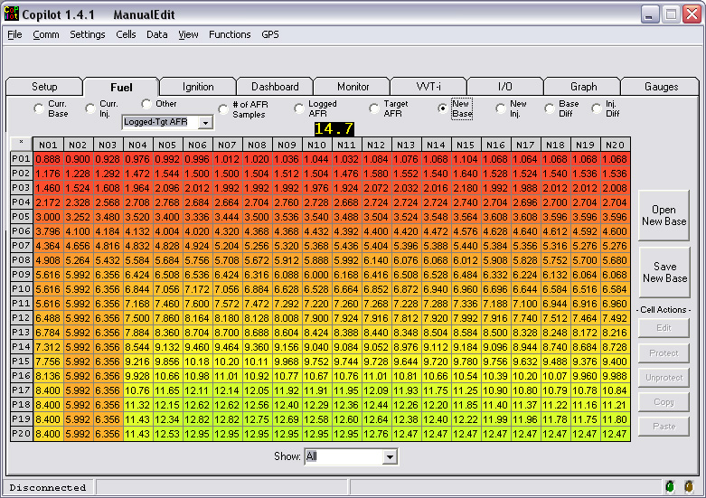
Select New to see Tom’s maps and Current to see your rescaled maps. Select Diff for each type of map to see the differences (Toms minus yours). My examples are as follows:
Tom’s Base Map. This looks very familiar! I think it is the same as what I started out with. At the time I had a different intake (MAF tube just like stock, except made out of aluminum) and my engine ran very rich with this base map (which is much richer than the default 2ZZ-GE map from the Datalogit user’s group). I set up a Target AFR map that was more reasonable and used Copilot to Auto Tune and hit the Target AFRs. Later, I changed the intake to one the same inside diameter as a 2.75” O.D. Injen, changed to an ITG oiled filter, and built a big airbox. So I had to do the Auto Tune again to change the base map so that it was once again hitting the Target AFRs. Also, what I started out with was an Inj map that was all 1.0. It looks to me like this is the same data that I started with, but I will have to check my old files.

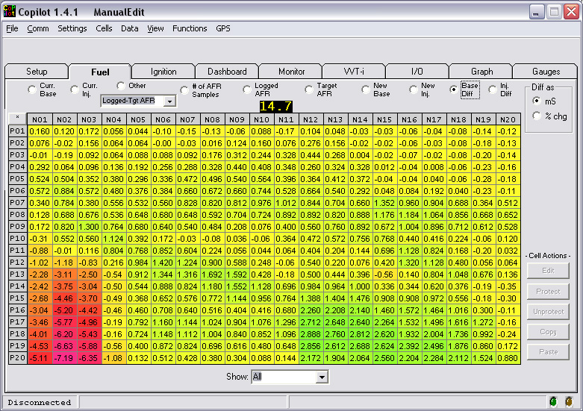

Tom’s Base Map minus my rescaled Base Map. The bottom left corner of the original base map that I got from LittleRocket looked like that, too. I changed it by manually editing to be more in line with the rest of the map in higher load and lower RPM cells. I only logged data in that area a few times, so as far as I am concerned, it doesn’t matter. I think it is unreachable because the RPM is 1500 or less and the load is very high. After lifting the throttle it might go into that area of the map briefly, but the injectors get cut off when you lift the throttle, so I don’t see how this matters. The rest of the map is mostly richer than mine… quite a lot in some areas. Notice that there are smaller differences in the middle (where it is more yellow than green). This is an area that I care about and had a lot of samples that were analyzed. The RPM range there is from around 3000 to 6100 (before lift, where most driving is done). I actually had far more samples in the upper left corner and I think the differences there and most other parts of the map before lift engagement are due to having a different Target AFR. I don’t know what AFRs JesseIL’s engine had, but his Inj map would be a clue. It would be a pretty big clue because when I ran with a base map like that, the AFR was right around 10 most of the time, sometimes in the 11s, sometimes even in the 9s. But it is quite possible that this base map is right for some combination of other things (intake, airflow curve, …). In other words, it has some consistency and other than the big blob off to the bottom left, could be used with an Inj map such that the Inj map commands the AFRs by the formula:

AFR = 14.7/Inj
Here are screenshots of my base map and Tom’s next to each other, for another comparison.
Mine
Tom’s

To be continued

Part IV – Starting a New Auto Tune Phase

To be continued

