How To Auto Tune Ignition Timing Using Copilot

I. INTRODUCTION

1.1 Credits
I’d like to thank the legendary Spyderchat member Little Rocket (David) for telling me how relatively low levels of knock should be treated. Paraphrased, “If you retard timing and the knock goes away, it was real knock and bad for your engine, long-term”. That’s why I developed the Find Insignificant Knock feature. Even more thanks go out to Spyderchat member Tem, who hosts the software and has been helpful with sage advice and testing of Copilot right from the inception.

1.2 Reference Information

Refer to the “sticky” topic in the Spyderchat Engine Management forum for more information on Copilot for PowerFC, a free program for Windows which uses a Datalogit interface (available from http://www.monkeywrenchracing.com and directly from Datalogit in New Zealand). The Copilot sticky is quite old, so some of the information is outdated because the program kept changing, with new features being added and old features being redesigned. There is a User’s Guide for the program on http://www.mr-s.org/copilot but again, that’s outdated information. “How To” topics for Copilot on Spyderchat and How To documents like this in mr-s.org will be kept up to date as the program changes.

1.3 Purpose

This document will serve as a guide to auto tuning (auto adjusting) ignition timing, be it combined with auto tuning the base map to achieve the desired Air/Fuel Ratios (AFRs) or not. It will not cover things like “What’s the best timing for my engine?” because quite frankly I do not know. ☺ My purpose here is solely to explain what can be done and how to do it using the program.

It is a good idea to read some of the great tuning topics on Spyderchat. Kingspyder, one of the first PowerFC gurus I’ve met, combined an awful lot of information on the PowerFC into one topic. There are also many books on the subject of tuning modern engine management systems. I do not call myself a tuner. I am a Systems Engineer who understands how the PowerFC works, how the Datalogit interface works, and how to write software. My focus is making software that helps people (tuners, n00bs, and anyone in between) accomplish their goals. My priorities are keeping my engine running well with as little knock as possible, making good power, and not wasting money on gas, so any advice I give reflects that concern for a healthy engine above all other considerations. It is a dangerous game we are playing, though, due to a flaky PowerFC interface, the fact that seemingly random hardware faults do occur in electronics, and very complex software is likely to have a few bugs.

1.4 The Knock Input, as Treated by the PowerFC and Copilot

1.4.1 Knock, Defined

True knock noise is caused by pre-detonation. This occurs when the spark and/or AFR and/or valve timing is adjusted badly as well as when the tuning is “perfect”, yet abnormal conditions exist. For example, abnormally high cylinder temperatures, bad gas, a dirty MAF sensor, clogged injectors, and so on can cause knock. Knock is bad for the engine – enough said. Knock sounds like marbles flying around inside a tin can when it reaches an audible level. If you can actually hear the knocking, it is definitely more than you want, so don’t let it continue. Retard the timing right away, noting where it occurred in the map, then figure out what the timing and other engine parameters should be later. If you have Copilot running, it will retard the timing for you and keep track of where it was and how many degrees it retarded.

1.4.2 Knock Input

There is a knock sensor installed in the engine, which is really just a microphone. It picks up all kinds of noise but some of this is filtered out by the PowerFC. I can only guess how effective that is for other people with different cars, but for my engine and my knock sensor, it works quite well. The PowerFC can tell there is knock, but it will not retard timing or enrich the air/fuel mixture when it occurs. All it will do is flash the Check Engine Light (CEL) if the number that it comes up with representing the amount of knock exceeds some threshold. This threshold is preset to 60 for a 1ZZ-FE engine but can be changed in the PowerFC for 2ZZ-GE and other engines.

How the PowerFC treats knock and all the other data you have programmed into it is both good and bad. It is good because you, not the computer, have complete control. It is bad because if something goes wrong - oops! I suggest buying a J&S Safeguard if you have forced induction and can find a unit for sale.

Copilot reads the latest knock along with other, related information in an Advanced Data packet. It does this quite a few times a second – perhaps 10 or more, depending upon how fast your laptop is, what other applications are running (hopefully none), and what else the program has to do. Reading the knock and responding to it is a high priority, but the time between successive reads is affected by everything else happening on the laptop (within Copilot and external to it as well). Copilot allows you to control its display update rate via the Settings menu and you can make other selections affecting the time between Advanced Data packets. I will cover the factors that determine how often Advanced Data is read later on in the document.

1.4.3 Reliability

After the raw knock input is filtered by the PowerFC, some of the noise is gone, but it can still show spikes from a bad shift. It is very rare for this to happen if you are careful about shifting, but Copilot has some logic to distinguish between knock that can probably be ignored (“Ignored Knock”) and knock it should pay attention to “Real Knock”. These two classes of knock are actually displayed in separate Logged Knock maps and separate counters are maintained for them. Real Knock is also subdivided into different subcategories, depending upon the level and whether or not it can be eliminated by retarding timing. Copilot also has a Knock Sensor Response Curve that you can set up to compensate for the fact that higher numbers maybe be reported, even after filtering, for higher RPMs.

As of version 3.7.2, Copilot only retards timing for you. It does not advance timing for safety reasons. Although it may be safe for it to advance timing most of the time, I don’t feel as though the reliability of the whole hardware/software system in terms of response time is good enough to risk other peoples’ engines. The program could crash or become unresponsive. The PowerFC or Datalogit could stop responding to read requests altogether or for an unacceptable time. Brief delays, lasting about a second (possibly several seconds) have been observed. In fact, this appears to be par for the course with the PowerFC, possibly because it is doing higher priority things like controlling the timing (it has less time to do this at high RPM). Additionally, the knock sensor may be bad or not screwed in tight, or you may not have entered a good Knock Sensor Response Curve, any of which could cause knock inputs to Copilot to be wrong, perhaps lower than they should be. If timing were advanced erroneously or even a little too far (causing knock) and then not responded to (retarded) in a timely manner, the system of which the software is part would not act in a manner that is safe for you engine.

While I am on the subject of PowerFC / laptop communications reliability, there are good reasons to be confident that the whole system of which the software is a part behaves safely, provided you have not made any glaring errors and the hardware itself is good. The PowerFC validates each packet (a read or write request) it receives and responds to bad packets with a Negative Acknowledge (NAK) instead of taking the requested action. It also sends a positive Acknowledge (ACK) after most types of write requests, such as map writes. Likewise, Copilot validates packets received, reports all errors to the user (in the message log and in a small panel at the bottom of the main window), and retries failed read requests. Copilot will continue to retry read requests, perhaps resorting to reinitializing the interface, before continuing with another read (or write) request. It is almost always successful and although read ‘glitches’ do occur, there does not seem to be any clear pattern. It may run for hours without a read glitch and the very next day, experience quite a few in just a few minutes time. On the writing side, the one we should be most concerned about, I have never seen any evidence of the PowerFC accepting bad data sent to it. I have intentionally and unintentionally sent it bad packets and they were all rejected. In summary, after many hundreds of hours of reading and quite a few writes, I/O appears to be safe, but unreliable in terms of response time… and not considering possible software defects or hardware faults.

1.5 Precautions

I have to caution people not to interact with the program while driving. I really do because I’d feel terrible if someone were to get into an accident because they were paying too much attention to a laptop. The program is named Copilot for two reasons. 1.) It is a far better thing for your copilot (a tuning partner) to interact with it than for you to do so. 2.) If you do not have a tuning partner, the program can be your copilot, doing everything automatically after being set up… and it only takes a few seconds to set it up each time you drive. In fact, if all you are going to do is log data to be replayed and/or analyzed later, you do not have to do a thing. Even if you are going to auto tune and/or look at maps and displays as you drive, it is no worse than operating the diver information display of a Toyota Prius. I put an incredible amount of work into making it work this way.

I urge people to back up their PowerFC data using FC Edit, saving to a .dat file, before beginning to use Copilot for the first time and on a periodic basis while doing any kind of tuning.

Do not allow the laptop to suspend/hibernate while Copilot is reading from the PowerFC. If you want to hibernate: Stop Acquisition, hibernate, come out of hibernation, then Start Acquisition. This can be done at any time. Copilot does not come out of hibernation gracefully if I/O was taking place when it hibernated. This is a known Windows problem affecting any program that uses Comm ports.
II. PREPARATION

Before you do any auto tuning of ignition timing in response to the knock input – or do anything with timing via manual editing, the recommended checklist is as follows. All steps are optional. Ones that I feel are more important are in bold.

- Verify that the knock sensor input to the PowerFC is good. A loose sensor will skew the output. For the Toyota MR2 Spyder, there is a torque specification in the Repair Manual that states:

Toyota MR2 Spyder:

Spec: 29 ft/lbs (39 NM)

Your Engine:

Spec: ___ ft/lbs (__ NM)

- Find out what type of knock sensor you have. What is considered a minimum knock level for this sensor and engine? _____ For my 2ZZ-GE swapped MR2 Spyder, using the Spyder’s stock knock sensor, it is less than 10 for the entire RPM range, with an occasional number in the low teens, depending upon conditions. Is the sensor’s response RPM-dependent (e.g., gets louder as RPM increases) and if so, by how much? ___________________ For my sensor and engine, numbers start out around 1-4 at low RPM and increase to around 10 linearly as RPM increases. If necessary, define a Knock Sensor Response Curve. (Refer to Appendix A.)
- Verify your wideband sensor is working/calibrated if you will be adjusting AFR (auto tuning or manual editing) at the same time.
- Observe knock as you drive (better yet: log data and replay it later) to see what you are dealing with. Is there any audible knock? ____ (If so, let off the throttle.) Does the CEL flash? _____ What is the maximum number you see in the Logged Knock map (with the radio button set to display the Max knock in each cell) using Copilot? ______ Note that if you use the Apexi FC Commander, it may show different numbers than you will see using Copilot. The FC Commander may be reading the Basic Data packet’s knock instead of the Advanced Data packet’s knock. “Basic knock” is unfiltered, I believe, so it may be higher than “Advanced knock”. People have reported differences and this could explain it.
- Compare your ignition timing map… and other maps… to those of others with similar setups. Is your data different? ____ Do you know why that is? _____
- Modify the Minimum Ignition map. If a file with this data does not exist when the program starts, one is created which allows each cell to be retarded by 6 degrees compared to the Current Ignition map at that time. From this point on, Copilot looks at the numbers in this map, not relative values (degrees relative to the Current Ignition map) for the limits of what it can do to the timing. You can change this map at any time (except when replaying, when you cannot change any maps), even while the knock response process is running. Why do we want a minimum level to be established for each cell? Since the program responds automatically to knock, we would not want a very high knock level, which could be “just noise” instead of actual pre-detonation, to retard the timing by a tremendous amount. For every map that Copilot is allowed to decrease values in automatically, there is a minimum map. Likewise, for every map it is allowed to increase values in automatically there is a maximum map.
- For platforms (engines) which have not been tested before, verify that Copilot can read and write the Ignition map. (Refer to paragraph ___.)
- Set up Copilot to minimize the time it spends doing anything other than responding to knock. (Refer to Appendix B.)

This page is reserved for your notes.
III. THE KNOCK RESPONSE PROCESS

It is important to understand how Copilot goes about responding to knock. All of the details presented here should be of interest to someone. Not all of it will of interest to everyone, but I encourage you to read as much as you can stand. ☺ I will give an overview first and then go into detail so you will know exactly what to expect from the behavior and how to control it properly. If I were to describe these in more detail now, you would find a lot more ands, ifs, and buts in the sentences, so just keep that in mind. The overview information is duplicated in the detailed description, so it may be skipped.

Note: Text Like This indicates additional information which is part of the New Ignition map data structure and is saved with the map file. Displaying and clearing/resetting of this information is described in Section IV.

Quick Overview

A knock number is received and corrected for by the curve. A determination is made as to whether or not the knock should be paid attention to (“Real Knock”) or can be ignored (“Ignored Knock”). Ignored Knock is shown in a dedicated map, but not otherwise responded to.

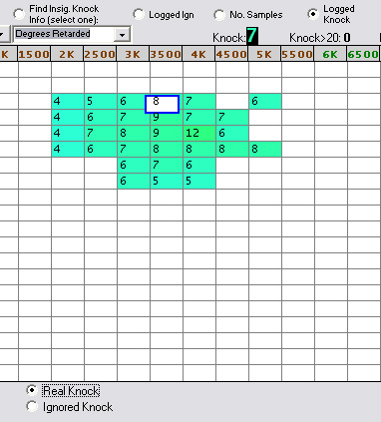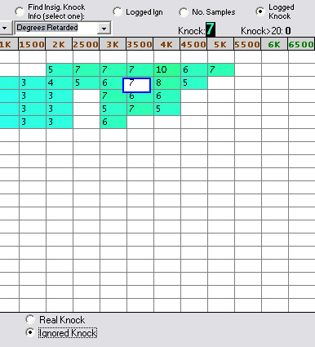
Displaying Real Knock (left) and Ignored Knock (right) for the same data.

Let’s assume it is Real Knock for now. What happens next depends mostly upon which knock response feature, if any, is responsible for this level of knock and the logic for each feature. At most one feature will be active for any knock sample, the highest priority one. In order of decreasing priority, they are:

  - Emergency (High Knock) Retard, Quick Overview

This feature can be enabled/disabled, but not by a check box. If the corrected knock number is greater than or equal to the High Knock Threshold and enough values like this have been seen for the cell since the cell was last modified in the PowerFC, a degrees-to-retard value is calculated based upon how high the corrected knock number is. The new, retarded, value for ignition is calculated from the current ignition map and degrees-to-retard. This is limited to the Min Ignition map value. The cell is then updated in the PowerFC and a record is kept of what was done.

  - Auto Tune Ignition Timing, Quick Overview

This feature can be enabled/disabled by a check box. If the corrected knock number is greater than or equal to the Knock to Cause Retard Threshold (and less than the High Knock Threshold, since that case was already handled) and enough values like this have been seen for the cell since the was last modified in the PowerFC, the response is almost identical to the above for Emergency Retard. Unlike the case with Emergency Retard, protected cells are not changed and different messages are generated. Cell protection will be described later on.

  - Find Insignificant Knock, Quick Overview

This feature is enabled/disabled by a dedicated check box – and also (is subservient to) the overall check box for Auto Tune Ignition Timing, making the overall check box a convenient way to enable/disable all but the Emergency Retard feature. It is very challenging to describe the Find Insignificant Knock feature in just a few easy-to-understand sentences. It is a lengthy, per-cell process than can be started, paused, resumed, or restarted from scratch. It can even be interrupted (by exiting the program) without the program losing track of what it had already done for each cell - how many degrees it retarded and other information telling exactly where it was in handling each and every each cell. There is a little bit more intelligence here than for the other features. What it does, in a nutshell, is find out which cells have actual knock, not just some other type of sound that made it past the PowerFC’s noise filter, and make it just barely stop knocking. Find Insignificant Knock finds out how many degrees to retard each cell based upon the knock level and whether or not retarding timing in the past made a noticeable difference in the knock level. You enter a number telling it what knock level it can safely ignore and can change this number anytime you want, except for the fact that past results are just that - past results.

Each cell is handled independently. As a knock value for a particular cell is received, the intermediate results/status of the cell it is associated with is examined and updated, possibly resulting in retarding the cell by 1 degree. When it is known what the insignificant knock level is for the cell, the cell’s status is set to Found Insignificant Knock (done). There is way for you to see the status and other info for each cell in a map and I will illustrate that later. (There is no check for all unprotected cells being done, however, since some cells cannot be reached and it is impossible to tell which ones they really are.)

When this cyclic process is finished for all cells, the ignition map will end up retarded by at least 1 degree in every cell visited that had a non-ignored knock value above the specified level. Cells which were never visited or never had a non-ignored knock value above the specified level will not be changed.

Detailed Description

  - The Knock Response Process in Detail

a. Inputs

The inputs, besides the just-received knock number, are as follows. “UI” denotes a User Input. The figure below shows the control inputs, which are located on the Setup tab.

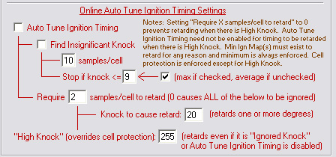

- Current Ignition map¹
- UI: Minimum Ignition map¹
- UI: Three thresholds for knock, which should be in increasing order:
  - Insignificant knock threshold, which is used by the Find Insignificant Knock feature. See “Stop if knock <= X” in the figure.
  - Knock threshold that should cause timing to be retarded, if the Auto Tune Ignition Timing feature is enabled. See “Knock to cause retard” in the figure.
  - High knock threshold, which is used by the Emergency Retard feature
- UI: For the Find Insignificant Knock and Auto Tune Ignition Timing features:
  - Enables (check boxes)
- For the Find Insignificant Knock feature only:
  - Information that is even retained between program runs, such as current and previous knock levels (max, average), and counters for each cell. These can be displayed via the Find Insig. Knock Info selection and drop-down list. Also the Finding Insignificant Knock and Found Insignificant Knock flags are inputs (see the figure in the Outputs section).

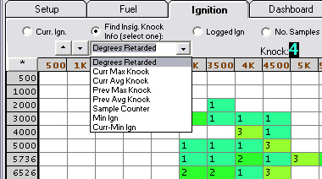

  - UI: Whether to consider the maximum or average of the knock samples it keeps track of while finding insignificant knock. This input applies when deciding whether or not to keep retarding the cell.
- Degrees Retarded, which is also retained between program runs.
- The RPM and Load (also known as PIM) from the Advanced Data packet which tells precisely where in the maps the PowerFC was operating (what data it was using) at the time all of the Advanced Data was received²
- For Auto Tune Ignition Timing and Emergency Retard only:
  - UI: “Require X samples/cell to retard”: The number of knock samples above the threshold which must have occurred before it will retard the timing. If this is set to 0, both features will be disabled. This is the only user input which can disable the Emergency Retard feature. (Actually setting the High Knock Threshold to a very high number like 255 can effectively disable it, but it is better to set that number to what you want for Emergency Retard.)
- UI: Knock Sensor Response Curve (Refer to Appendix A)
- Logged Knock map (previous values or min, max, average, sums, and number of samples). This is both an input and output – it is updated and referred to in other ways.

Note 1: For 1ZZ-FE engines, there are two ignition maps labeled “Leading” and “Trailing”. Only one of these maps actually works, the one labeled “Trailing”. The program acts as though both maps work and treats them the same way, retarding both by the same amount. They are completely independent and fully functional as far as Copilot is concerned, even though only one of them is actually used in the PowerFC. You should have a unique Minimum Ignition map file for each one. The memory for the map does in fact exist in the PowerFC and data can be stored there and read back. If you allow the automatic knock response features to run, though, whatever you had stored there would be modified like it would be for a functional map. A future version of Copilot will eliminate the code related to auto tuning this map because handling the I/O for it wastes time, but may retain the ability to display, edit, read, write, save, etc. For the remainder of this document, no further mention will be made of the “useless” 1ZZ-FE Leading ignition timing map.

Note 2: RPM and Load serve as precise “addresses” into all the maps, each of which is a 3-D surface defined by an array of 20 by 20 data points. The 400 points are also called cells. I use the term “points” to help you visualize the 3-D surface and understand the role of interpolation. Interpolation is the calculation of a value for “height” or “amount” on the 3-D surface, given the height of the 4 closest points and the address. Copilot works the same way as the PowerFC in this respect.

b. Outputs

- Ignition maps (the Current and New maps in Copilot’s memory and the one in the PowerFC)
- For the Find Insignificant Knock feature only:
  - Information that is even retained between program runs, such as current and previous knock levels (max, average), counters, and the Finding Insignificant Knock and Found Insignificant Knock flags for each cell.
- Other information that is retained between program runs for each cell:
  - Degrees Retarded
  - High Knock, Retarded flag: whether or not the cell was ever retarded due to High Knock
  - Knock, Retarded flag: whether or not the cell was ever retarded due to any other level of knock
  - Min Limited flag: whether or not retard was ever limited by the Min Ignition map. (These cells are displayed with a different color text.)

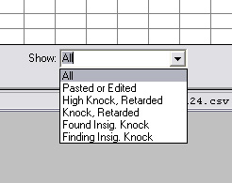

Displays for the User Interface could also be thought of as “outputs”, but are described later in this document.

c. Processing

A knock number has been received as part of the Advanced Data packet and is corrected for by the curve. Limit Check Alerts processing (comparing data received to limits the user has defined, taking the desired actions) is performed. Note that because the Limit Check Alerts processing is done for the Advanced Data Packet, including knock, before a determination is made as to it being real or ignored knock, you will get alerts for “Ignored Knock”, too. This is intentional.

Note that much of this processing also occurs when you are in Replay Mode, replaying a data log. The knock number and all other Advanced Data came from the data log in that case. The other differences are that even though the knock type is determined in Replay mode, the ignition map is not changed and of course nothing is written. When working in Online mode and connected, the data came from the PowerFC and may be acted upon.

A determination has to be made as to whether this is “Real Knock” or should be ignored. “Ignored Knock” is saved in a different Logged Knock map than the one used for Real Knock, but not otherwise responded to. If it is “Real Knock”, how should we treat it? The various tests are described next. This is actually quite complex logically – far more that even I would have guessed when I began working on it.

Next the program answers the question:

Should the knock be ignored and if not, what category of knock is it insofar as our processing is concerned?

Stale Data Test:
The time since the last Advanced Data packet is examined to see if it was received more than 0.6 seconds after the previous Advanced Data packet. If it has been longer that this, the knock is “Ignored Knock” and no other tests are performed. Here is why: The PowerFC keeps track of the max knock since it was last read. If it has been too long, the knock that was just read is “stale data” and we cannot assume that the RPM and Load tell us precisely (to the nearest cell) where the knock occurred! If we don’t know where it occurred, it would be wrong to retard timing in a cell in the same general area (or perhaps very far away). Although we may miss seeing some knock immediately due to the stale data check, if the cell is causing the knock, we will most likely see it again later when the data isn’t stale. We cannot know in advance that we will see it again in this part of the map anytime soon because we do not know how the person is driving, but chances are we will and it would certainly be wrong to retard the wrong cell.

Emergency Knock Test:
If all of these conditions are met, the knock will be treated as Emergency Knock, otherwise more tests will be done for other knock response processes.
Knock is above the Knock to Cause Retard Threshold
Knock is above the High Knock Threshold
RPM is above 2000
Load is above 2000
Engine is warmed up (water temperature is at least 140F)
RPM is not dropping very quickly at all

The explanations for these conditions are as follows. It is very unlikely that a person’s maps are so far off that the engine is knocking at low RPM or Load. Furthermore, when I (and others I’ve talked with) have seen a knock spike due to a bad shift, the Load has been very low. Load drops very rapidly while shifting because the clutch is pressed. A rapid or even moderate rate of RPM drop may indicate a shift. Even if this is not the case, if a cell is “visited” while RPM is dropping slowly, chances are that the cell will be revisited while RPM is increasing. If the engine is not even warmed up yet, the person could be parked and just playing with the gearshift. Besides, the engine runs differently while warming up.

Knock Eligible for Auto Tune Ignition Timing Test:
If all these conditions are met, the knock will be eligible to be handled by the Auto Tune Ignition Timing process:
Knock is above the Knock to Cause Retard Threshold
RPM is above 2000
Load is above 2000
Engine is warmed up (water temperature is at least 140F)
RPM is not dropping very quickly at all
A gear change is not likely to be occurring right now or recently

The “a gear change is not likely…” check is far too complicated to explain here, but it is a more effective way of detecting knock which can occur during a gear change, even after the RPM has dropped. Since it is not really possible to know for certain if the noise was due to a gear change, the Emergency Knock test does not depend upon this condition being true.

Now we know what category of knock it is:
- Ignored Knock
- Emergency (High) Knock (which may not be enabled)
- Not Emergency (High) Knock (we will call this “Nonemergency Knock”) - eligible for the Auto Tune Ignition Timing process (which may not be enabled).
- All other non-ignored knock - eligible for the Find Insignificant Knock process (which may not be enabled)

Knock counts are kept track of for each cell, in case the “Require X samples/cell to retard” user input is greater than 1. There are separate counters for use by the Emergency Knock and Nonemergency Knock processes. These counters are cleared for a cell when the cell is finally retarded and written to the PowerFC and at other times.

Whichever of these two types it is, Emergency or Nonemergency, the Overall Knock Counter, which is displayed at the top of the Ignition tab, is updated at this time so the user can tell how many knocks there have been. (So you can quickly note the number, pay attention to driving, and recheck the number later.) This Overall Knock Counter is reset to 0 at different times, such as when you select Data → Cleared Logged Data or Log → New Data Log, or, in Replay Mode, open a new data log. There is also an Ignored Knock Counter for ignored knock that is above the threshold for Auto Tune Ignition Timing. This is also cleared when the Knock Counter is cleared and displayed on the Ignition tab. It is displayed primarily to allow me to evaluate the performance of the knock tests.

Overall Knock Counter, Ignored Knock Counter, and Cells Written Counter

If it is time to update whichever map is selected for display, it is updated at this time. Use the Settings menu to change the Update Rate to a slower rate optimize for knock response time.

If working in Online Mode, the Online Auto Tune process is run. I will describe that soon. After that, if data logging is enabled (which implies Online mode), Advanced Data is appended to the Data Log, the History arrays are updated, and if either the small or large chart is visible and enabled for display, the appropriate one is updated.

That is the complete processing of Advanced Data insofar as knock is concerned. Now let’s look at the Online Auto Tune process.

Before doing the online auto tuning of fuel injection (described in another document), if that is enabled, the knock is handled. The requirements for entering this process are:
It is not ignored knock
The Current Ignition map has been read and is valid
The New Ignition map has been read (or created) and is valid
The Min Ignition map has been read (or created) and is valid¹

Note 1: Valid means that all cells have valid numbers in them. No assumption is made about any cells which may be greater than or equal to the current ignition map, which would prevent any retard at all.

Online Auto Tune Ignition (Pseudocode)

If it was previously determined that this is Emergency knock
If not disabled by Require X Samples/Cell to Retard being 0
If there have been enough High Knock samples for this cell
Do Emergency Knock Process
End if
End if
Otherwise, if it is Nonemergency knock, the following is done
If not disabled by the Auto Tune Ignition Timing check box
If the knock is higher than the Knock to Cause Retard Threshold
If not disabled by Require X Samples/Cell to Retard being 0
If enough Nonemergency knock samples for this cell
Do Nonemergency Knock Retard Process
End if
End if
Otherwise (knock is not higher than the Knock to Cause Retard Threshold)
If not disabled by the Find Insignificant Knock check box
Do Find Insignificant Knock Process
End if
End if
End if
End if
Each of these processes is described in detail below.

d. The Emergency (High Knock) Retard Process in Detail

A degrees-to-retard value is calculated based upon how high the corrected knock number is.

Corrected Knock | Degrees-to-Retard
1-19 | 1
20-39 | 2
40-59 | 3
60-79 | 4
80-99 | 5
etc. | etc.

The new, retarded, value for ignition is calculated from the Current Ignition map and degrees-to-retard. This is limited to the Min Ignition map value. Whenever the Min Ignition map limit is encountered, the degrees-to-retard value is also reduced, because this number is added to the current Degrees Retarded information in the New Ignition map data structure and we want that to reflect the total number of degrees actually retarded.

Also, the Min Limited flag is set for the cell. Since this knock value is above the High Knock Threshold, another flag is set - the High Knock, Retarded flag. Note that the information is updated with the assumption that the I/O would complete successfully, so if you experience I/O errors, the information as to what was done to each cell may be wrong. Also, a warning message, Warning: High Knock in ignition map cell(row, col) was limited to the Min Ign Map, is written to the message log and one of the status panels at the bottom of the main window will say: Auto Tune Ignition Warning in case you do not have the message log window open. If the degrees-to-retard is reduced to 0 (meaning the cell cannot be changed at all because of the Min Ignition map), there will be no writing to the PowerFC and the process ends prematurely.

If it is not limited by the Min Ignition map, a different warning message is written to the message log, Warning: High Knock in ignition map cell(row, col), and the status panel will say High Knock, Retarded.

Before writing to the PowerFC, something else needs to be done. Since the cell is being retarded by a process other than the Find Insignificant Knock process, we need to ensure the data integrity of the Find Insignificant Knock process, which was based on different timing. Most of the information is cleared/reset. If the process is currently enabled (by the check box), the process is restarted from scratch for this cell. Although this seems unnecessary because cells are only retarded, it is proper and there may be a day when one of the processes is allowed to advance the timing.

The cell is then updated in New Ignition map, with all other cells simply copied over from the Current Ignition map. It is not possible to write just once cell, so the entire map has to be written. Data Acquisition has to be paused to prevent more data from being read while writing and reading maps is taking place. The High Knock counter for this cell is cleared. The New Ignition map is then written to the PowerFC. The program waits up to 3 seconds for the ACK (acknowledge) to be received from the PowerFC, indicating a successful write. Normally the ACK is received right away. If NAK is received, an appropriate warning message is generated for the user. If no ACK is received (no response at all), a different warning message is generated. But the normal course of events is to receive the ACK and you will see ACK displayed in a small panel at the bottom of the main window.

The Ignition map is then read back from the PowerFC. (Copilot always reads back the data it wrote so that current information is kept up-to-date. It does not assume the write was good even though ACK was received.)

The number of ignition map cells written is update on the Ignition tab. Also a message,
High Knock, retarded cell (row, col) by N degrees is written to the message log even though the I/O may have failed. This coming immediately after a warning about the I/O tells you which cell it was and how many degrees it would have been retarded.

If the Ignition tab isn’t already selected, the program will select the Ignition tab for you. Also, if the main window was minimized, it will be restored. This is to alert you to the fact that a cell was retarded. Cells which have been retarded recently will have a bold red border that flashes on/off quickly for a few seconds. You do not have to be displaying Logged Knock to see the flashes. The cell border(s) will flash no matter what map you are looking at on this tab.

e. The Nonemergency (Auto Tune Ignition Timing) Knock Retard Process in Detail

This process is actually very similar to the Emergency Retard process, with the following differences:
- Map protection is observed (see below).
- The High Knock Retarded flag is not set. Instead, a Knock Retarded flag is set. Note: If neither of these flags is set, but the Degrees Retarded is greater than 0, that means it must have been retarded due to the Find Insignificant Knock feature, which does not have its own flag to indicate that any retarding was done.
- Some of the messages generated differ.

Map Protection

Cells in the Ignition map can be protected from most changes, whether they are initiated by you (editing, pasting into a map, editing a curve) or the program. The PowerFC also has the ability to protect maps (as a whole, not individual cells), but Copilot does not use that capability, in fact it removes any such protection it finds during startup. We are talking about software-enforced protection and it does make sense to override that at times, such as in the case of very high knock, which is why protection has not been discussed very much until now.

During both the Auto Tune Ignition Timing and Find Insignificant Knock processes, if the cell the knock is in is protected, nothing further is done… no flags are set, the maps are not changed, and no messages are generated. It is that simple. There is a completely separate Limit Check Alert process that occurs after the Advanced Data is received and validated, however, and if you have a limit check defined for knock, the action(s) for that condition being met will be taken, such as a pop-up alert. I think it is a good idea to define such an alert for knock greater than, say, 20 or 30. You can even define multiple limit checks for different knock values and have it take different actions. But back to discussing Map Protection…

Protection flags are also part of the New Ignition map data structure. In order to set or clear protection flags, you have to have New Ign selected for display. Then simply select one or more cells by defining a rectangular area. Click and drag the mouse to define the area, just as you would to edit, copy, paste, smooth, etc. a group of cells. If you right-clicked and dragged, a pop-up menu will appear when you release the mouse button, so choose Protect or Unprotect from the menu. If you left-clicked and dragged, follow that by clicking the Protect or Unprotect button to the right of the map.

(insert picture)

f. The Find Insignificant Knock Process in Detail

(Fill in later)

Ignoring the fact that some cells cannot be reached and some cells shouldn’t be changed in this way (you should protect those from being changed by this process), if you want to have your timing map, say, “2 degrees from knock”, you would first manually advance timing (by editing and writing) until you see what you think is a small amount knock in every cell that isn’t protected and you are able to reach while driving. You would then enable this feature, let it run to completion, and then manually retard all the cells that are Done another 2 degrees. That would actually make some cells 2 degrees from knock and others (the ones it retarded) 2 to 3 degrees from knock. Another, quicker approach is to assume that the cells with no significant knock when you start out are fine, let the process run to completion, then retard the cells that the program retarded another 2-3 degrees, possibly smoothing out the map in between those cells.

  - Special Considerations

User Inputs

(image here of part of Setup tab)

Saving Maps to Files

The program does automatically save maps to files at certain times, but it does not do this when a map is changed due to auto tuning or, for that matter, editing. This is because file I/O takes time and would impact the time to respond and time between Advanced Data packets. Since the information about what was done to each cell is part of the New Ignition map data structure (not written to the PowerFC, just the file), it is a good idea for you to save this map once in a while if there have been changes made, in case the program should crash (quite rare, but it can occur) or something happens to Windows or the laptop itself. Use the File menu (File → Save All) or, since you are most likely looking at the Ignition tab, select the New Ign map for display, the click the map save button, which will then have the label “Save New Ign Map”.

(image here of button)
IV. MAPS AND OTHER IGNITION/KNOCK DISPLAYS

Current knock is shown color-coded at the top of the main window along with AFR and Slip. It is also shown color-coded above the map on the Ignition tab along with knock counters and number of ignition map cells written.

The maps which can be displayed on the Ignition tab are:

- Current Ignition – what is in the PowerFC at present
- Find Insignificant Knock Information and other maps:
  - Total Degrees Retarded by any of the retard processes… not just Find Insignificant Knock
  - Intermediate values used during the process (see list in figure below)
  - Min Ign: Minimum Ignition map
  - Curr-Min Ign: Difference between the Current and Minimum Ignition maps (Current minus Minimum or “headroom”)
Note: These last two are not specific to the Find Insignificant Knock process. I just needed a place to put more choices and putting the minimum and “headroom” map here is consistent with the use of the “Other” display option on the Fuel tab.

Find Insignificant Knock and other map choices

- Logged Ign: Logged Ignition degrees – min, max, or average (3 different maps). The source of this data is the Advanced Data packet.
- No. Samples: Number of samples (of logged knock and logged ignition)
- Logged knock – min, max, or average of the Real Knock or Ignored Knock (6 different maps!)
- New Ign: New Ignition map – the scratchpad area that the retard processes use and which you can edit and write while not doing data acquisition.
- Ign Diff: Difference between the New and Current Ignition maps (New minus Current)

The Show drop-down list at the bottom of the window selects which numbers are displayed in:
- All of the Find Insig. Knock Info and other maps in the upper drop-down list
- New Ignition map
- Ign Diff map
but not the Curr Ign, Logged Ign, Logged Knock, No. Samples, or Logged Knock maps. You can tell when the Show drop-down list can be used because it only appears when it can be used. All of the data for whichever map is selected will be color-coded no matter what the selection is here, but only the numbers for the Show option will be displayed. Basically, if the selected flag in the New Ignition map data structure is set, the number will be display, except for the All choice, which will just display numbers without considering the flags.

An example of using the two drop-down lists together is below. This is a color-coded map of Degrees Retarded, with numbers filled in for cells retarded because of Emergency (High) Knock, Auto Tune Ignition Timing (“Knock, Retarded”), and Find Insignificant Knock.

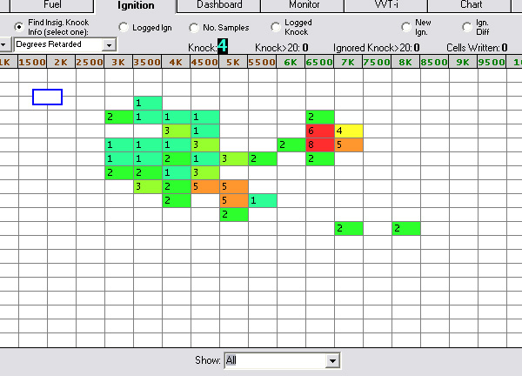
Degrees Retarded map, Showing All

Compare this to the display of the same Degrees Retarded data with different selections for the Show option on the next page.
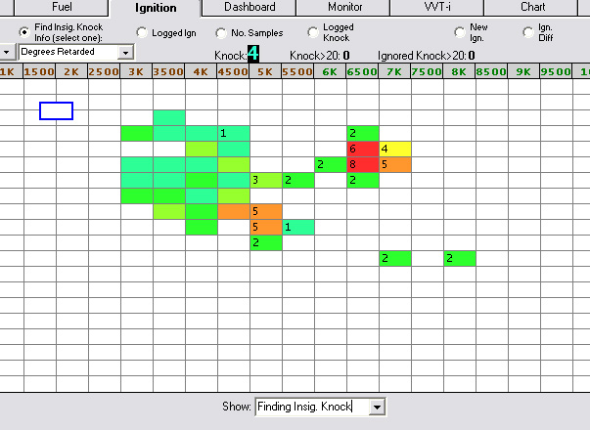
Degrees Retarded, Showing “Finding Insig. Knock”

The above shows numbers for only those cells which the Find Insignificant Knock feature is in the “Finding” state. The feature may or may not be active right now, of course. You can see information this way even when working offline, since it is in the New Ignition map file.

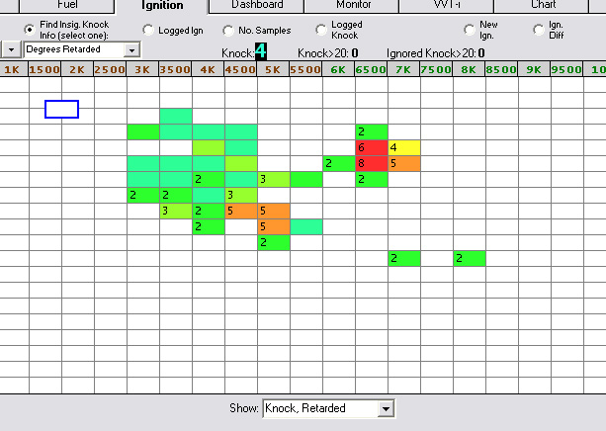

The above shows numbers for only those cells which the Auto Tune Ignition Timing feature retarded.
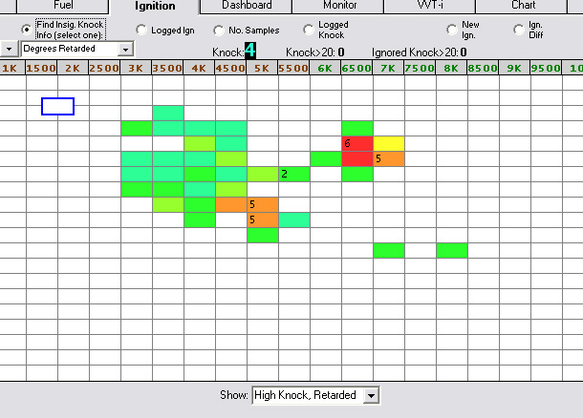

The above shows numbers for only those cells which the Emergency (High) Knock feature retarded.
Appendix A – Defining a Knock Sensor Response Curve

To define a Knock Sensor Response Curve, or to define other calibration factors, select Settings → Calibration… from the main window. The Calibration Factors window will appear.

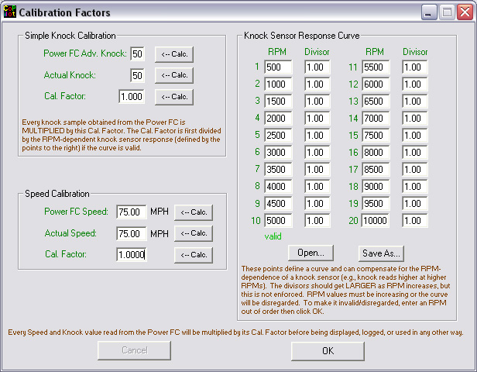

You can either define a Simple calibration factor, which is a constant that raw knock inputs are multiplied by, define a 20-point curve, or both.

For Simple calibration, you need to enter any two of the parameters and click Calc button for the other one. For example, if you (or someone else with the same engine and sensor) installed a better knock sensor that indicates that the stock sensor you are using now reads 60 when it should be 50 (using the better sensor), you would enter 60 for the Power FC Adv. Knock, 50 for the Actual Knock, then click the bottom Calc button.

If you read the brown text for the Knock Sensor Response Curve, it explains how that works. You can also enter 1.0 for every divisor (like the default settings) to make it so the curve is ignored.

All this information is saved in the Registry and loaded whenever Copilot starts. If you want, you can also save to a file on the disk and open files.

Speed Calibration works the same way as Simple Knock Calibration. The Power FC reports the actual speed of the vehicle more accurately than the speedometer. The speedometer of all cars sold in the US is supposed to read 3MPH higher. You would not use this for that, since you want to know the actual speed. You would use this if you have different wheels or tires, for example. You might be able to get the actual speed from a speed warning sign and of course you can compute it from measured mile signs on the highway and time intervals. I would use perhaps 10 miles on flat ground so it is easy to maintain a steady speed and drive at 75 MPH.

